CHARACTERISTICS STUDY OF SIDE BAND POWER AND FREQUENCIES IN AM USING MATLAB

OBJECTIVES:
i) To generate an Amplitude Modulated (AM) signal in MATLAB using specified carrier and modulating signal parameters.
ii) To determine and verify the upper sideband (USB) and lower sideband (LSB) frequencies of the AM signal using frequency spectrum analysis in MATLAB.
iii) To calculate the carrier power, sideband power, and total transmitted power of the AM signal for a given modulation index using MATLAB.
iv) To analyze the effect of varying the modulation index on sideband power distribution and overall transmission efficiency through MATLAB simulation.

PROGRAM (MATLAB CODE)
clc;
clear;
close all;
Am = 1;
fm = 500;
Ac = 5;
fc = 5000;
fs = 20*fc;
t = 0:1/fs:4/fm;
% Message signal
m = Am*sin(2*pi*fm*t);
% Carrier signal
c = Ac*sin(2*pi*fc*t);
% Modulation index
mu = Am/Ac;
% AM signal
am = Ac*(1+mu*sin(2*pi*fm*t)).*sin(2*pi*fc*t);
% Demodulation using envelope detection
env = abs(am);
window = round(fs/fc);
dem = movmean(env, window);
dem = (dem - Ac*2/pi)*(pi/Ac);
% Frequency spectrum
N = length(am);
f = linspace(-fs/2, fs/2, N);
AM_FFT = abs(fftshift(fft(am)))/N;
% Sideband frequencies
USB = fc + fm;
LSB = fc - fm;
% Power calculation
Pc = Ac^2/2;
Psb = (mu^2*Pc)/4;
% Plotting
figure('Name','AM Modulation','NumberTitle','off');
subplot(3,2,1);
plot(t,m);
title('Message Signal');
grid on;
subplot(3,2,2);
plot(t,c);
title('Carrier Signal');
grid on;
subplot(3,2,3);
plot(t,am);
title('AM Signal');
grid on;
subplot(3,2,4);
plot(t,dem);
title('Demodulated Signal');
ylim([-1.5 1.5]);
grid on;
subplot(3,2,5);
plot(f,AM_FFT);
xlim([fc-3*fm fc+3*fm]);
title('Sidebands');
grid on;
subplot(3,2,6);
bar([Pc Psb Psb]);
set(gca,'XTickLabel',{'Carrier','USB','LSB'});
title('Power');
grid on;
% Display results
fprintf('Modulation Index = %.2f\n',mu);
fprintf('USB Frequency = %d Hz\n',USB);
fprintf('LSB Frequency = %d Hz\n',LSB);
fprintf('Carrier Power = %.2f W\n',Pc);
fprintf('Each Sideband Power = %.3f W\n',Psb);

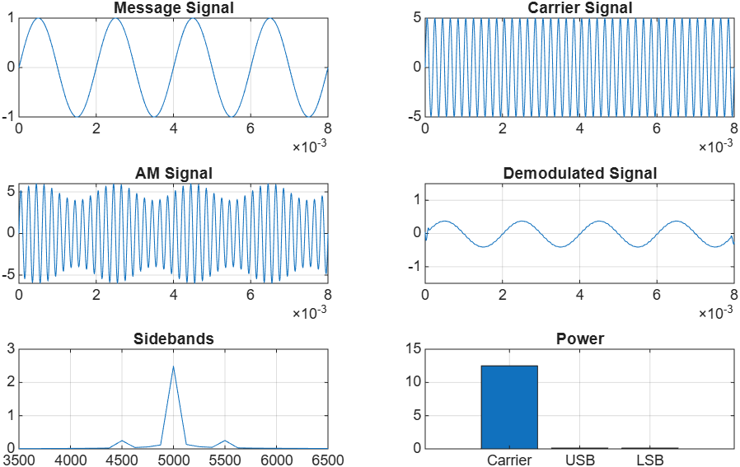
OUTPUT (GRAPH)

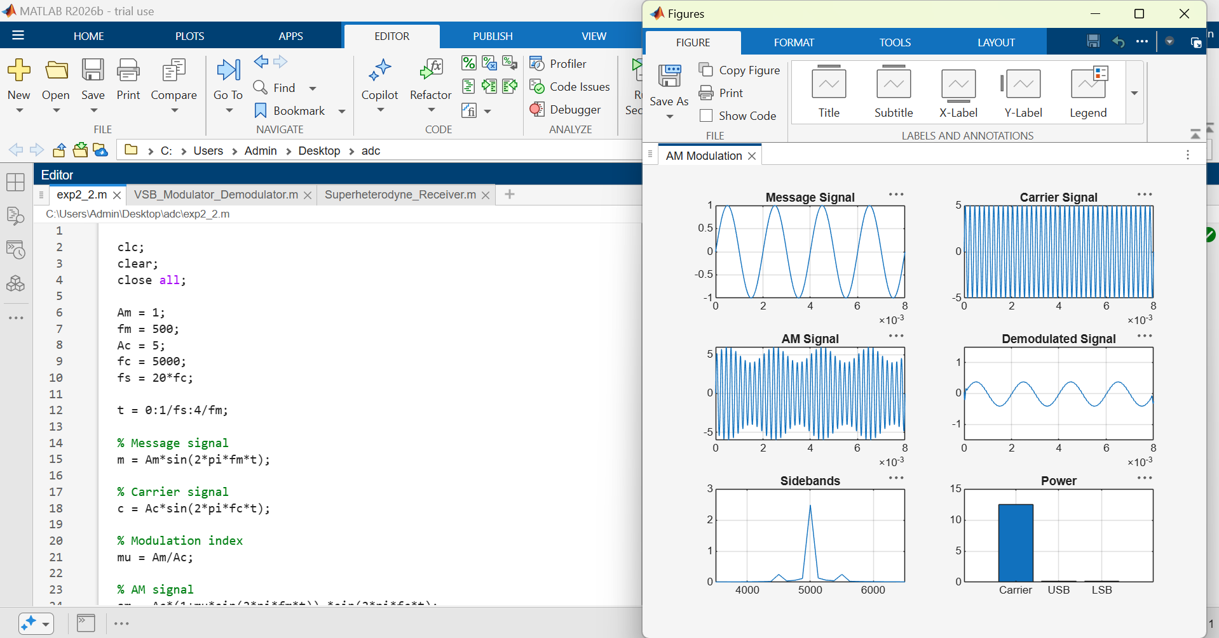
RESULT:
The AM signal was successfully generated and analyzed in MATLAB.
- Upper Sideband Frequency (USB) = $f_{c}+f_{m}$= 5500 Hz
- Lower Sideband Frequency (LSB) = $f_{c}-f_{m}$= 4500 Hz
- Carrier Power = 12.5 W
- Upper Sideband Power = 0.125 W
- Lower Sideband Power = 0.125 W
- Total Sideband Power = $0.125+0.125$= 0.25 W
- Total Transmitted Power = $12.5+0.25$= 12.75 W

